Youtube Tutorial Videos

Microsoft Visio
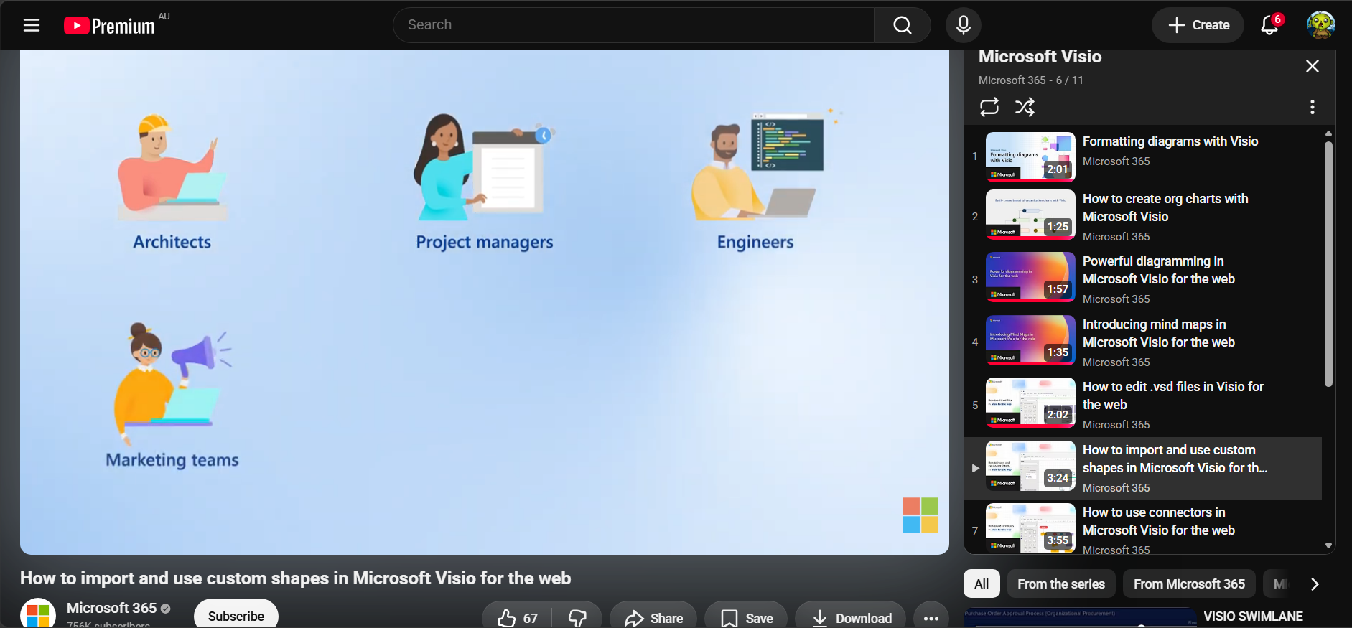

BPMN Diagram Tutorial in Lucid
